Personal Financial Position & Property Acquisition Strategy – Joel (as of Aug 2026)
Executive Summary
This document presents a comprehensive overview of my current financial position and evaluates viable pathways to transition from living at home.
Key Financial Strength
As of August 2026, my total combined asset portfolio stands at $303,100, consisting of $132,115 in cash reserves, $50,724 in long-term managed funds, and $120,260 in superannuation. I carry $0 in liabilities, having fully paid off my $17,500 HECS debt in December 2025.

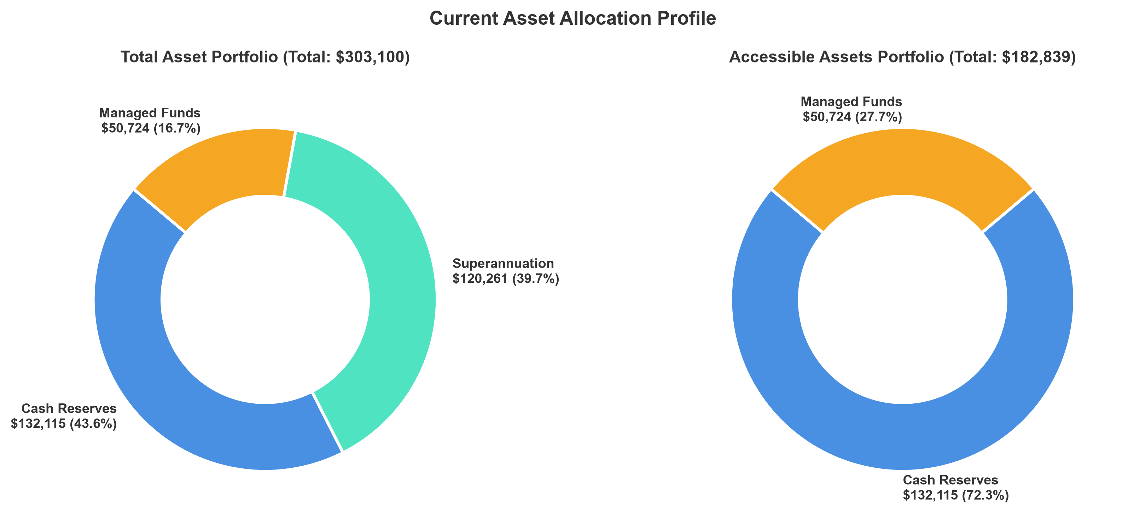
Figure 1: Current asset allocation profile, comparing total assets including superannuation (left, $303,100) and accessible liquid wealth excluding superannuation (right, $182,839).
1. Current Assets & Demographic Benchmarking
To evaluate progress against the broader Australian economy, my asset position has been benchmarked against official data from the Australian Bureau of Statistics (ABS) and the Australian Taxation Office (ATO) for the 25–29 age bracket:
- Superannuation: Balance is $120,260.82. The national median superannuation balance for individuals aged 25–29 is approximately $19,500, while the average (mean) is $27,500 (skewed upward by outliers). My superannuation is therefore over 6x the median and over 4x the average of the same demographic. Sources: ATO Taxation Statistics (https://www.ato.gov.au/about-ato/research-and-statistics/) and ASFA Superannuation Statistics (https://www.superannuation.asn.au/resources/superannuation-statistics/)
- Liquid Cash & Savings: Cash reserves are $132,115, compared to a typical national median savings balance of approximately $10,000 and an average of $20,000 for this age bracket. This puts liquid cash reserves at over 13x the median and over 6x the average, providing an insulated, self-funded buffer to manage property purchase costs and unexpected life events independently. Source: Finder Savings Account Statistics (https://www.finder.com.au/savings-account-statistics)
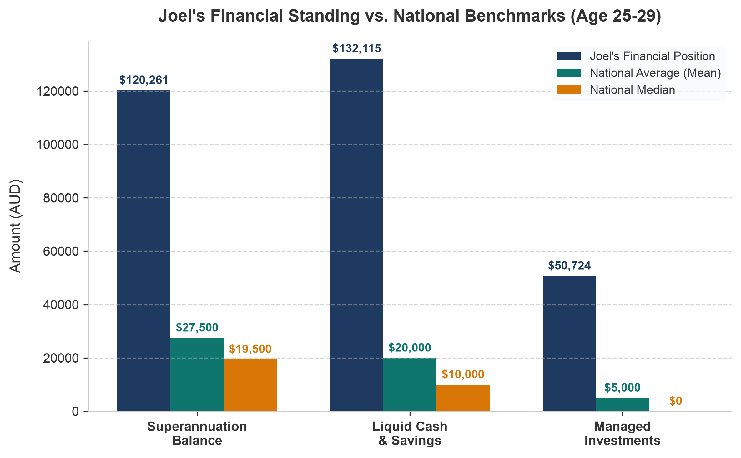
Figure 2: Joel's asset comparison against national average (mean) and median benchmarks for the 25–29 age demographic.
2. Employment, Income & Tax Structure
Salary is set at Higher Education Officer (HEO) Level 9, Maximum Step. Full base salary is $160,430 as of July 1, 2026, and my total package is $187,703 when including the 17% employer superannuation contribution.
Median full-time earnings for 25–34 year olds is approximately $80,000 to $85,000. The tables below break down my tax liabilities and take-home pay structures under the current 2026–2027 Australian tax brackets.
Annual Tax Liability Breakdown (2026–2027 Rates)
Income Bracket | Tax Rate | Tax Amount (AUD)
$0 to $18,200 | 0% | $0.00
$18,201 to $45,000 | 16% | $4,288.00
$45,001 to $135,000 | 30% | $27,000.00
$135,001 to $160,430 | 37% | $9,409.10
Medicare Levy (2.0%) | 2.0% of Total | $3,208.60
Total Annual Income Tax |  | $43,905.70

Private Health Insurance (PHI) Tax Advantage
With a gross salary of $160,430, I fall into Tier 3 ($158,000+) for the Medicare Levy Surcharge (MLS). Without private hospital cover, I would incur a 1.5% surcharge ($2,406/year). By maintaining my current AHM private health insurance policy at ~$130/month ($1,560/year), I legally avoid this surcharge, resulting in a net tax saving of ~$846 per year.

Net Income & Take-Home Pay Analysis
Income Category | Amount (AUD)
Gross Annual Income | $160,430.00
Less: Total Annual Income Tax & Medicare Levy | -$43,905.70
Net Annual Income | $116,524.30
Gross Fortnightly Pay | $6,149.27
Net Fortnightly Take-Home Pay (Actual Pay slip) | $4,466.27

3. Savings Capacity & 12-Month Projections
To map out my savings trajectory over the next 12 months, three spending models have been established based on actual net fortnightly take-home pay ($9,710.36 equivalent monthly):
Scenario | Est. Monthly Spend | Monthly Savings | 12-Month Accum.
Optimistic (High Discipline) | $1,200.00 | $8,510.36 | $102,124.32
Base Scenario | $1,800.00 | $7,910.36 | $94,924.32
Pessimistic | $3,000.00 | $6,710.36 | $80,524.32

Pre-Purchase Savings Projection Model
The 12-month savings trajectories are calculated using a linear accumulation model based on my current starting cash reserves and monthly savings rates:
Mathematical Projection Formula
Cash(n) = Cash(start) + [n * (Net Monthly Income - Monthly Spend)]
Where:
• Cash(n) is the projected cash balance at Month n.
• Cash(start) = $132,115 (current cash reserves as of August 2026).
• Net Monthly Income = $9,710.36 (derived from my $160,430 gross salary minus $43,905.70 in annual tax and Medicare Levy).
• Monthly Spend is set based on the scenario: $1,200 (Optimistic), $1,800 (Base), or $3,000 (Pessimistic).

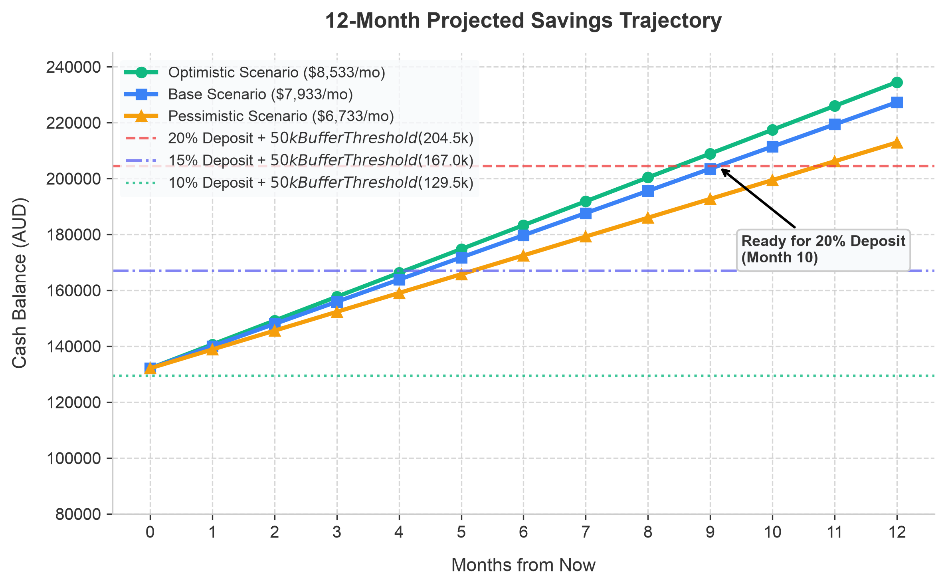
Figure 3: Projected cash balance over 12 months, showcasing 10%,15% and 20% deposit readiness.
4. Risk Management: The $50,000 Safety Net
The strategy is a liquid cash buffer of $50,000 post-purchase. This safety net will not be used for the property deposit or transaction costs. Its sole purposes are:
- Mortgage Protection: In the event of temporary income disruption, $50,000 represents approximately 14 months of mortgage interest payments under a base 6.00% p.a. interest rate, or 11 months of full principal & interest repayments under an 8.00% p.a. stress-tested rate.
- Emergency Buffer: Covers unexpected medical expenses, vehicle maintenance, or urgent property strata repairs without requiring credit cards or emergency liquidations.
- Holding Cost Insurance: Strata levies, council rates, water, and insurance are estimated at $600 to $700 per month. These will be absorbed via my regular net salary surplus, keeping the $50,000 buffer completely intact.
5. Property Acquisition Pathways (Target: $750,000)
Target is a 1-bedroom + 1-study apartment in the Castle Hill Showgrounds precinct or similar profile. Based on current market, residential developments in this precinct (such as Carrington Place, Grand Reve, or Castle Grange) offer premium 1 + Study configurations between $680,000 and $780,000. A baseline purchase price of $750,000 has been set for modeling. Under this baseline, three structured pathways have been mapped out:
Financial Metric | Option A:  Buy Established Now | Option B:  Off-The-Plan Now | Option C:  Accumulate (12 Mos)
Deposit % / Amount | 10% / $75,000 | 10% (Now) -> 20% (Settle) | 20% / $150,000
Federal Gov. Scheme | First Home Guarantee (FHBG) | N/A (Off-the-plan timing) | N/A (20% deposit achieved)
Lenders Mortgage Ins. | $0.00 (FHBG Waived) | $0.00 (Settle with 20%) | $0.00 (20% deposit avoids LMI)
NSW Stamp Duty | $0.00 (FHBAS Exempt) | $0.00 (FHBAS Exempt) | $0.00 (FHBAS Exempt)
Total Upfront Cash Req. | ~$79,500 (Incl. fees) | ~$79,500 (Now) + $75k | ~$154,500 (Incl. fees)
Remaining Buffer | $52,615 (Safety buffer met) | $52,615 (Now) -> $154k+ | $72,539 (Safety buffer met)

Strategic Policy Update: First Home Guarantee
Following the removal of the $125,000 individual income cap on 1 October 2025, I am fully eligible for the Australian Government's First Home Guarantee (FHBG). The scheme guarantees up to 15% of the property value for eligible buyers. This allows me to purchase an established property immediately with a 10% deposit (Option A) and pay $0.00 in Lenders Mortgage Insurance (LMI), which typically costs $9,000 to $16,000 at this Loan-to-Value Ratio (90% LVR).

6. Mortgage Stress Testing & Cash Flow Analysis
I have stress-tested my monthly scenarios post-purchase. This modeling assumes a loan principal of $600,000 (assuming a 20% deposit is achieved via Option B or Option C) or $675,000 (under Option A with a 10% deposit). The calculations below model the $600,000 loan balance and compare a standard 6.00% p.a. interest rate against a highly conservative 8.00% p.a. interest rate scenario (stress test):
Monthly Budget Line Item | Base Case (6.00% Rate) | Stress Test (8.00% Rate)
Net Monthly Take-Home Income | $9,710.36 | $9,710.36
Less: Mortgage Repayments (P&I) | -$3,597.30 | -$4,402.58
Less: Holding Costs (Strata/Rates) | -$600.00 | -$700.00
Less: General Living Expenses | -$1,500.00 | -$3,000.00 (Doubled)
Remaining Net Monthly Surplus | $4,013.06 | $1,607.78

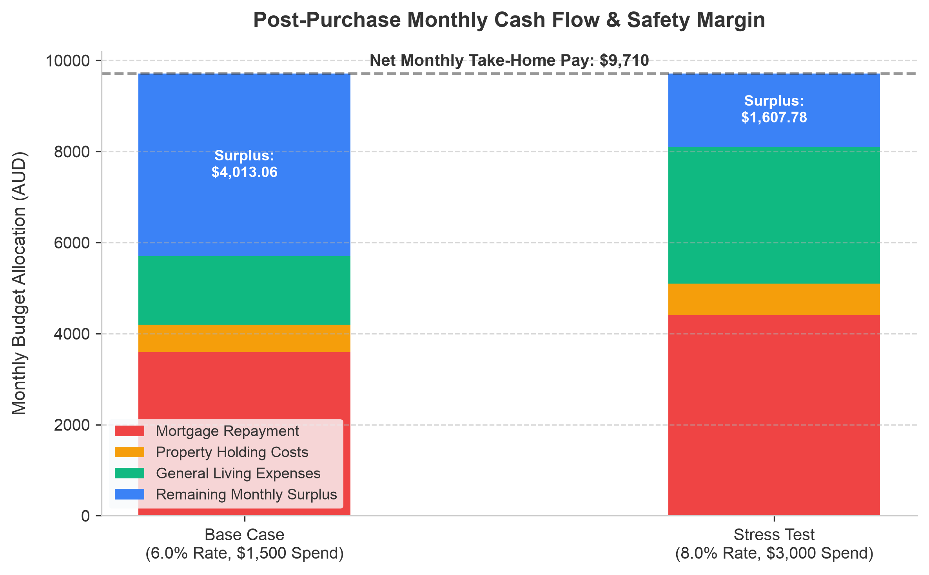
Figure 4: Post-purchase monthly cash flow allocation showing comfortable surplus levels.
Insight: In the worst-case scenario where interest rates rise to 8.00% and my general living expenses double to $3,000 a month after moving out, my monthly cash flow remains positive by $1,607.78. Under all circumstances my $50,000 safety buffer will remain entirely untouched.
Borrowing Conservatism (Debt-to-Income Ratio): To further mitigate risk, my borrowing profile is structured to remain highly conservative. A key metric used by the Australian Prudential Regulation Authority (APRA) and major lenders to evaluate debt risk is the Debt-to-Income (DTI) ratio, calculated using the standard formula: DTI = Total Credit Limit of All Debts / Gross Annual Income.
Under this formula, a DTI below 5.0x is classified as low-risk. Under the 20% deposit model (loan of $600,000), my DTI is 3.74x ($600,000 mortgage / $160,430 gross base salary). Under the 10% deposit model (loan of $675,000), my DTI is 4.21x ($675,000 mortgage / $160,430 gross base salary). Both scenarios sit substantially below the APRA 6.0x high-risk threshold, which is considered a safe borrowing margin. Sources: APRA Macroprudential Policy Framework and APRA Credit Risk Guidelines (https://www.apra.gov.au/key-financial-indicators).
6.1 Post-Purchase 10-Year Wealth & Asset Growth Projection
To evaluate long-term financial trajectory post-purchase, a monthly balance sheet simulation has been modeled over a 10-year horizon. This model assumes that my monthly surplus cash flow is placed entirely into a mortgage offset account, which reduces interest charges and accelerates principal reduction. The modeling compares the Base Case against the severe Stress Test Case under the following compounding settings:
- Base Case Growth Rates:
- Property capital growth at 3.0% p.a.
- Superannuation at 6.5% p.a.
- Managed Funds at 7.0% p.a.
- Surplus cash flow of $4,013.06/mo is deposited into the offset account (effectively earning 6.00% tax-free interest).
- Note: The 3.0% p.a. property growth is a conservative unit-market baseline representing the Castle Hill Showground apartment corridor. While the overall suburb median is $1,105,000 (reflecting a general 13.9% growth rate), the specific segments for Castle Hill units show a median price of $687,050 for 1-bedroom units and $965,000 for 2-bedroom units. Performance is highly segmented, high-supply cycles saw 2-bedroom growth flatten to 0.4% p.a. To build a defensive strategy, we model a conservative 3.0% p.a. growth baseline. Source: realestate.com.au Castle Hill Suburb Profile (https://www.realestate.com.au/nsw/castle-hill-2154/)
- Stress Test Case Growth Rates:
- Property capital growth at 1.0% p.a.
- Superannuation at 5.5% p.a.
- Managed Funds at 6.0% p.a.
- Surplus cash flow is limited to $1,607.78/mo deposited into the offset account (earning 8.00% interest).
- Note: The 1.0% p.a. property growth represents a flat-market stress test where the apartment experiences almost zero capital gains over 10 years.

6.1.1 The Mortgage Offset Account Strategy & Mechanics
The post-purchase strategy is the use of a linked Mortgage Offset Account. Rather than placing surplus savings into standard savings accounts (where interest is low and taxable), all available funds goes to this offset account. The mechanics of this strategy are structured as follows:
- Input Structure: The account starts with the $50,000 cash buffer post-purchase. Fortnightly salary will go directly to this account, and all ongoing expenses will be drawn from it, keeping the net balance maximized. The monthly surplus cash flow (Base Case: $4,013.06/mo; Stress Case: $1,607.78/mo) will accumulate here.
- Impact on Interest Calculations: Interest is only calculated on the net difference between the loan balance and the offset balance: Net Interest Owed = (Loan Balance - Offset Cash) * Monthly Interest Rate.
- Acceleration of Principal Reduction: While the bank's scheduled monthly repayment remains fixed, the portion of that repayment going to pay interest is reduced by the offset balance. The saved interest is automatically applied to reduce the loan principal. This creates an accelerating compounding loop and saving interest costs.
Offset Account Numerical Example:
A scenario at Month 1 where the remaining mortgage loan principal is $600,000 and the offset account has accumulated $50,000 in cash. The bank calculates interest only on the net balance of $550,000 ($600,000 loan - $50,000 cash). At a 6.00% p.a. interest rate (which is 0.50% monthly), the monthly interest charge is $2,750 instead of $3,000, saving $250 in interest in the first month. Since the scheduled monthly P&I repayment remains fixed at $3,597.30, the saved $250 is automatically applied to pay down the loan principal. In Month 1, instead of reducing the loan principal by $597.30, the principal is reduced by $847.30 ($597.30 baseline principal repayment + $250 interest savings).
Net Worth in scenario planning is calculated as: Net Worth = (Property Value + Superannuation + Managed Funds + Offset Cash) - Remaining Loan Balance. The following results demonstrate a compounding effect across the three tiers of my wealth:
Tier 1: Post-Purchase Cash Flow & Offset Projections (Liquid Cash)
This tier measures my liquid cash reserves (starting with my $50,000 safety buffer post-purchase) from a micro and macro sustainability perspective:
- Micro Perspective (Short-Term Monthly Cash Flow): Monthly budget remains highly sustainable. In the Base Case, it retains a monthly surplus of $4,013.06. Even under the Stress Test (8.00% rate, doubled living costs), I maintain a positive monthly cash flow surplus of $1,607.78. Under no scenario does my $50,000 safety buffer ever deplete.
- Macro Perspective (Long-Term Cash Accumulation): By putting the monthly surplus cash into the mortgage offset account, my liquid cash reserves grow rapidly. In the Base Case, offset cash grows to $290,784 by Year 5, and $531,567 by Year 10 (fully offsetting the remaining loan balance of $302,524 by Year 7.5). In the Stress Test, offset cash grows to $146,467 at Year 5, and $242,934 at Year 10 (offsetting 67% of the remaining $364,164 loan).
Tier 2: Accessible Liquid Wealth (Cash + Managed Funds)
This represents the total liquid and accessible wealth, excluding the home and superannuation. It represents capital that I can access at any time for other investments, opportunities, or lump-sum mortgage reduction. Superannuation is excluded here as it is a preserved asset:
- Base Case: Accessible liquid wealth grows from $100,724 at settlement (Year 0) to $362,692 at Year 5, and reaches $633,506 by Year 10. This provides me with a highly flexible liquid investment portfolio parallel to my property.
- Stress Test Case: Accessible liquid wealth grows from $100,724 to $214,886 at Year 5, and reaches $335,221 by Year 10. Even under adverse financial conditions, my accessible liquid assets more than triple in 10 years.
This represents accessible net worth, calculated as: Accessible Assets (Property + Managed Funds + Offset Cash) - Mortgage Liabilities. Preserved superannuation is completely excluded from this tier as it is locked until retirement:
- Accessible Net Worth (Base Case): Starts at $250,724 at settlement (Year 0). It grows to $732,228 at Year 5, and reaches $1,342,997 at Year 10. This demonstrates a highly robust liquid growth path and substantial home equity generation.
- Accessible Net Worth (Stress Case): Starts at $250,724 at settlement. It grows to $479,064 at Year 5, and reaches $799,901 at Year 10. Even under high interest rates and minimal unit growth, my accessible net worth increases by over $549k over the decade, proving the high safety margin of the strategy.
6.1.2 Balance Sheet Component Breakdown & Mathematical Logic
Accessible Net Worth numbers in Figure 5 (page 11) are calculated using the tables below, which outline the asset and liability component values at Year 0 (settlement), Year 5, and Year 10. Net Worth is calculated as: Net Worth = Total Accessible Assets - Total Liabilities, where Total Accessible Assets is the sum of Property Value, Managed Funds, and Offset Cash, and Total Liabilities is the Remaining Mortgage Loan Balance. This structured overview ensures no mixing of preserved retirement assets with accessible wealth.
Table 6: Base Case 10-Year Component Breakdown (6.00% Mortgage Rate, 3.0% Property Growth)
Balance Sheet Component | Year 0 (Settlement) | Year 5 Post-Purchase | Year 10 Post-Purchase
Property Value (3.0% p.a. Growth) | $750,000.00 | $871,212.59 | $1,012,015.16
Managed Funds (7.0% p.a. Growth) | $50,724.43 | $71,908.23 | $101,938.93
Offset Cash Balance ($4.0k/mo surplus + interest) | $50,000.00 | $290,783.60 | $531,567.20
Total Accessible Assets (A) | $850,724.43 | $1,233,904.42 | $1,645,521.29
Remaining Mortgage Loan (B) | -$600,000.00 | -$501,676.13 | -$302,524.46
Accessible Net Worth (A - B) | $250,724.43 | $732,228.28 | $1,342,996.83

Table 7: Stress Test Case 10-Year Component Breakdown (8.00% Mortgage Rate, 1.0% Property Growth)
Balance Sheet Component | Year 0 (Settlement) | Year 5 Post-Purchase | Year 10 Post-Purchase
Property Value (1.0% p.a. Growth) | $750,000.00 | $788,436.91 | $828,843.67
Managed Funds (6.0% p.a. Growth) | $50,724.43 | $68,419.66 | $92,287.86
Offset Cash Balance ($1.6k/mo surplus + interest) | $50,000.00 | $146,466.80 | $242,933.60
Total Accessible Assets (A) | $850,724.43 | $1,001,323.37 | $1,164,065.13
Remaining Mortgage Loan (B) | -$600,000.00 | -$524,259.58 | -$364,164.20
Accessible Net Worth (A - B) | $250,724.43 | $479,063.78 | $799,900.94

6.1.3 Alternative Strategy – Balanced Wealth Accumulation (Vanguard Regular Contributions)
The previous simulation model assumes that 100% of post-purchase surplus cash flow is directed to the mortgage offset account, leaving my long-term investment portfolio static.
To evaluate the trade-off between debt reduction and wealth creation, a second scenario (Strategy B) has been simulated: it establishes an automatic monthly contribution of $500.00 minimum into investments, while the remaining surplus cash flow ($3,513.06/mo in the Base Case) is directed to the offset account. The results at Year 10 reveal a clear financial trade-off:
Table 8: Strategic Comparison at Year 10 (Base Case Projections)
Strategic Metric | Strategy A: Offset-Priority | Strategy B: Balanced (Vanguard RSP)
Vanguard Fund Balance (Year 10) | $101,938.93 | $196,098.45
Offset Cash Balance (Year 10) | $531,567.20 | $471,567.20
Remaining Mortgage Loan (Year 10) | -$302,524.46 | -$315,452.50
Accessible Net Worth (Year 10) | $1,342,996.83 | $1,364,228.31
Mortgage Fully Offset Timeline | Year 7.5 (Month 90) | Year 8.3 (Month 99)

Key Strategic Insights: Strategy B (Balanced Allocation) results in a higher projected net worth at Year 10 by $21,231.48. This is driven by the positive yield spread between the Vanguard fund's long-term capital growth (7.50% p.a.) and the mortgage interest rate (6.00% p.a.). However, this comes at the cost of delaying the full offset timeline by 9 months (from Month 90 to Month 99). Additionally, interest savings in Strategy A are 100% tax-free, whereas Strategy B distributions are subject to annual personal income tax.

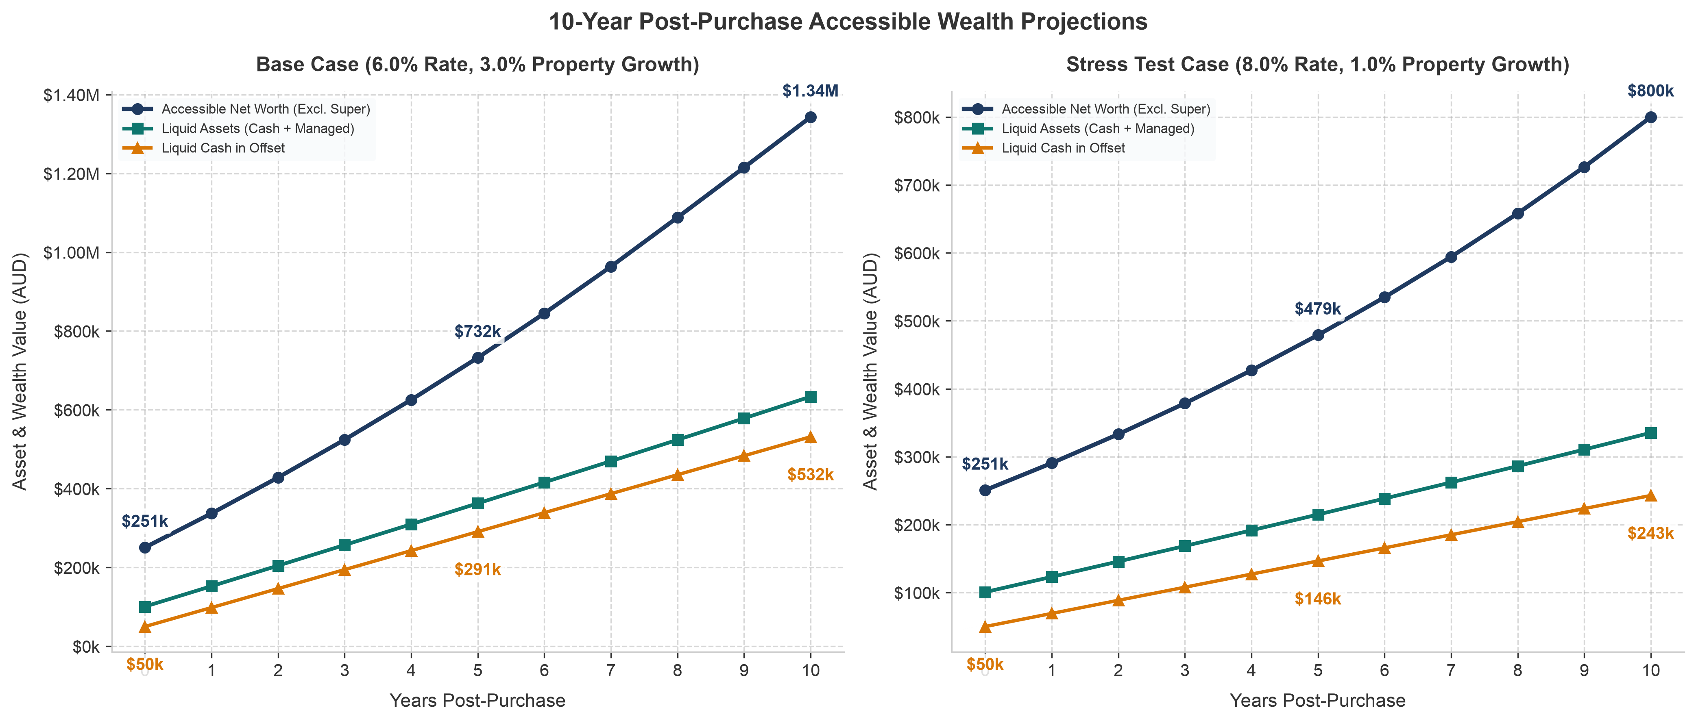
Figure 5: 10-year projected post-purchase wealth trajectory showing Liquid Cash, Accessible Assets (Cash + Managed), and Accessible Net Worth (excluding preserved superannuation) for both Base and Stress Test scenarios.
6.2 Standalone Preservation-Age Wealth (Superannuation Projections)
Superannuation is a preserved asset class. Superannuation is held with UniSuper and is 100% allocated to the High Growth investment option (approximately 90% growth assets and 10% defensive assets). This option is designed for high long-term capital growth and has historically delivered strong performance, with a 5-year annualized return of 8.27% p.a. and a 10-year annualized return of 10.84% p.a. as of 30 June 2026 (net of tax and investment fees). Under the University of Sydney HEO 9 package, you receive a 17.0% employer contribution rate. On the base salary of $160,430, this equates to $27,273.10 gross p.a. ($2,272.76 per month gross). After the standard 15% contributions tax, this results in a net monthly contribution of $1,931.84 deposited directly into your preserved super account. Sources: UniSuper High Growth Option Performance (https://www.unisuper.com.au/investments/investment-options/high-growth) and University of Sydney Salary Packaging Policy.
To model long-term retirement wealth accumulation, a standalone projection is run for the superannuation portfolio. Given the 100% High Growth allocation and historical averages, we assume an 8.00% p.a. compound growth rate in the Base Case (which is conservative compared to UniSuper's 10-year historical return of 10.84% p.a. to build a safety margin), and a 6.00% p.a. growth rate in the Stress Test Case (representing long-term market stagnation). The table below details the growth of your preserved retirement asset:
Table 9: Standalone Preserved Superannuation Projections (17% Contributions)
Superannuation Scenario | Year 0 (Settlement) | Year 5 Post-Purchase | Year 10 Post-Purchase
Base Case (8.0% p.a. growth + USyd HEO 9 contributions) | $120,260.82 | $321,115.60 | $620,358.22
Stress Test Case (6.0% p.a. growth + USyd HEO 9 contributions) | $120,260.82 | $296,998.36 | $535,390.82

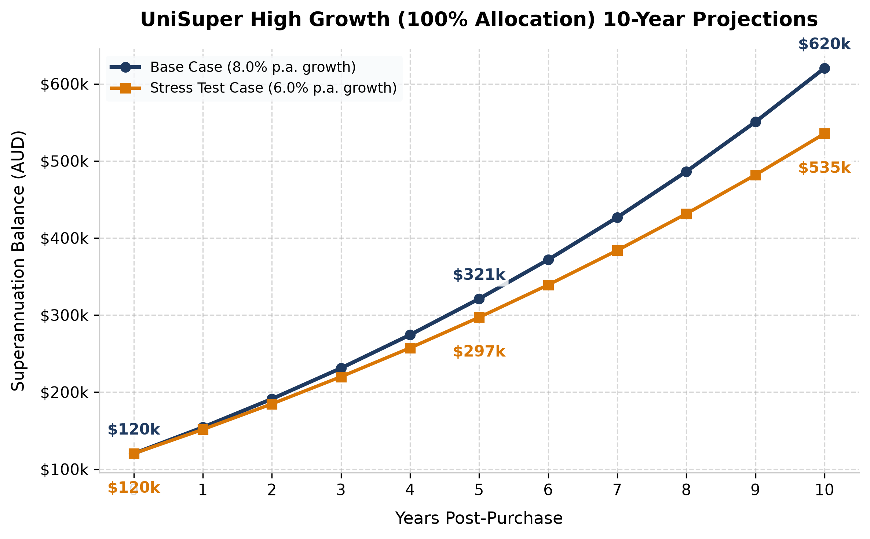
Figure 6: 10-year projected superannuation balance growth (UniSuper High Growth 100% Allocation) under Base (8.0%) and Stress Test (6.0%) scenarios.

7. Government Schemes & Property Acquisition Process
7.1 Government Assistance Schemes & Eligibility Summary
To minimize upfront purchasing costs, I can use primary government assistance programs. These are documented below with their official eligibility rules and sources:
- NSW First Home Buyers Assistance Scheme (FHBAS):
• Benefit: 100% full transfer (stamp) duty exemption for new or established homes valued up to $800,000, representing a direct saving of ~$29,000 on a $750,000 property.
• Key Eligibility: Must be a first-time buyer (never owned residential property in Australia), at least 18 years old, and an Australian citizen or permanent resident. I must move into the property within 12 months of settlement and occupy it for a continuous period of at least 12 months.
• Source: Revenue NSW Official Portal (https://www.revenue.nsw.gov.au/grants-schemes/first-home-buyer/assistance-scheme)
- Australian Government First Home Guarantee (FHBG):
• Benefit: Allows purchase with a deposit as low as 5% without paying Lenders Mortgage Insurance (LMI) by providing a government-backed guarantee for up to 15% of the property value. This saves $9,000–$16,000 in upfront costs.
• Key Eligibility: Must be an Australian citizen or permanent resident, at least 18 years old, and a first-time buyer. The individual income cap of $125,000 was abolished on 1 October 2025, meaning I am fully eligible under my $160,430 base salary. The property price in the Sydney metropolitan area must be capped at $1,500,000 (which fully covers the $750,000 target).
• Source: Housing Australia Official Portal (https://www.housingaustralia.gov.au/support-buy-home/first-home-guarantee)
7.2 Step-by-Step Acquisition Roadmap & Transaction Costs
The practical roadmap from initial preparation to final move-in is mapped below. The durations shown are based on standard real estate and legal parameters in New South Wales:
- Pre-approval processing takes 1 to 4 weeks (ASIC Moneysmart - https://moneysmart.gov.au/home-loans/pre-approval-for-a-home-loan)
- Property search and due diligence averages 8 weeks (Domain Buyer Index - https://www.domain.com.au)
- The 6-week (42-day) pre-settlement period represents the standard legal default contract term specified by the Law Society of NSW (https://www.lawsociety.com.au/for-the-public/buying-and-selling-property) and Real Estate Institute of NSW (REINSW).
Step 1: Engage a Mortgage Broker (Cost: $0.00 out-of-pocket)
A licensed mortgage broker will assess borrowing capacity across lenders. They are compensated via bank commissions upon settlement. (Source: ASIC Moneysmart - https://moneysmart.gov.au/home-loans/using-a-mortgage-broker)
Step 2: Obtain Formal Loan Pre-Approval (Cost: $0.00)
Secures a formal lending commitment from a bank. It confirms borrowing capacity, acts as a hard ceiling on my purchase price, and is valid for 90 days.
Step 3: Appoint a Licensed Conveyancer or Solicitor (Est. Cost: $2,000 – $3,000)
A conveyancer manages contract reviews, title transfers, and strata records checks. They will audit the strata scheme's financial history to ensure no special levies are pending. (Source: NSW Fair Trading - https://www.fairtrading.nsw.gov.au/housing-and-property/buying-and-selling-property/conveyancing)
Step 4: Due Diligence & Property Inspections (Est. Cost: $300 – $600)
For established units, a strata search report (~$300) is purchased. For off-the-plan, a professional builder's defect inspection (~$500) will be ordered to force the developer to remediate defects under statutory builder warranties before settlement. (Source: NSW Fair Trading - https://www.fairtrading.nsw.gov.au)
Step 5: Government Registration Fees (Est. Cost: $300 – $500)
Covers administrative costs to register the mortgage and transfer the title deed into my name. (Source: NSW Land Registry Services - https://www.nswlrs.com.au)
Transaction Fee Summary
To cover all transaction fees (conveyancer, inspections, and government registrations), a dedicated purchasing buffer of $4,500 is allocated. This is fully covered by my current cash reserves and does not affect the $50,000 emergency safety net.

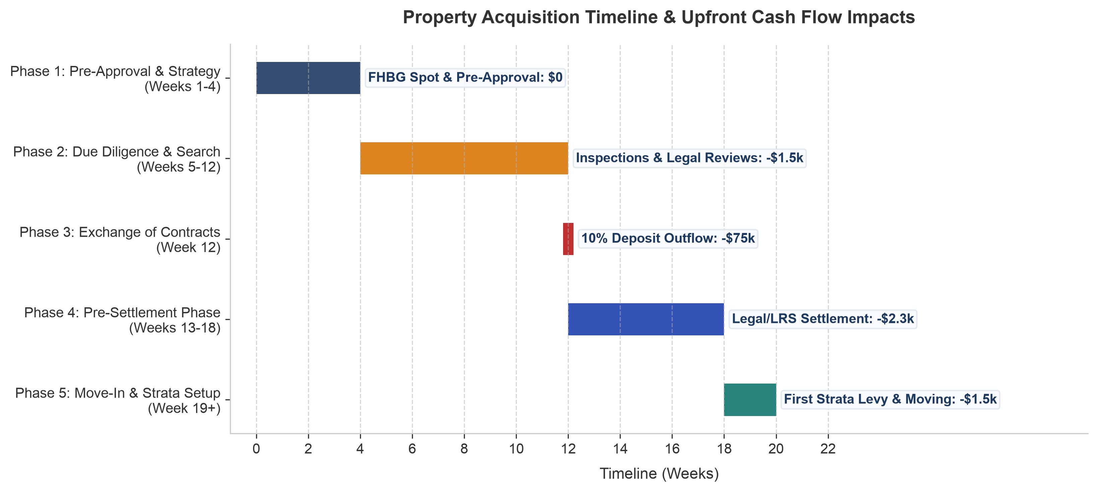
Figure 7: Property acquisition timeline showing key transaction stages and associated cash flow impacts.
7.3 Target Search Timing & Deposit Tier Projections
Based on the current cash position of $132,115 and a monthly savings capacity of $4,013.06, the property entry timing is somewhat flexible. The table below outlines three viable timing windows for starting active property searches depending on the target deposit tier (10%, 15%, or 20%):
Table 10: Search Timing & Financial Trade-Offs by Deposit Tier
Deposit Tier | Cash Required | Offset Cushion | Timeline | Strategic Trade-Off
10% Deposit (FHBG) | $78,300.00 | $53,815.00 | Immediate (Aug 2026) | FHBG reservation required; slightly higher monthly repayments ($4,047/mo).
15% Deposit (FHBG) | $115,800.00 | $50,000.00 | 8 Months (Apr 2027) | Reduces mortgage to $637.5k; cuts repayments by $225/mo to $3,822/mo.
20% Deposit (Standard) | $153,300.00 | $50,000.00 | 17 Months (Feb 2028) | Reduces mortgage to $600k; lowest repayments ($3,597/mo); no FHBG dependence.

Key Timing Strategy: I am financially positioned to start looking for properties immediately under the 10% deposit FHBG strategy. However, if I choose to wait just several months, I can step up to a 15% deposit. This provides a balanced middle-ground: it reduces the mortgage size and interest charges while still utilizing the FHBG scheme to avoid LMI, keeping my post-purchase safety net fully intact.

